# 

# **SQL Practice - OR OPERATOR**

Q:I require to determine the number of customers located in Pune OR Mumbai using OR Operator

A: SELECT * FROM Customer WHERE City='Pune' OR City='Mumbai';

| customer_ID | LastName | FirstName | Address | City |
| --- | --- | --- | --- | --- |
| 10 | chilka | Dinesh | 305 - 14th Ave. S. Suite 3B | Pune |
| 20 | Ram | sham | Keskuskatu 45 | Mumbai |
| 10 | Manohar | Dasri | ul. Filtrowa 6  8 |  |
| 10 | Amit | Silam | gharkul Solapur | Mumbai |
| 50 | Wilman | Kala | Kanna chowk | Pune |

**Examples For Pr﻿actice** : Suppose I have the first name "Dinesh" and the last name "Ram". Now, how can I retrieve the customer details from the customer table?

Answer Format 👍:

Name : Mitali Gupta [Ans: Select * from customer WHERE firstname='Pune' or city='Mumbai';]

Name : Sivasankaran [Ans : Select * from customer where firstname like ‘dinesh’ or lastname=’ram’;]

Name: Ranjith Kumar [Ans: select * from Customer where FirstName=’Dinesh’ or LastName=’Ram’;]

]

Name: Lahari Korsipati[ Ans:] SELECT * FROM Customer WHERE Firstname=’Dinesh’ or Lastname=’Ram’;

Name: Prathamesh Rane [ans];- SELECT * FROM Customer WHERE FirstName=”Dinesh” or LastName=”Ram”;

Name : Shubham Kumar Vishwakarma [ select * from customer where firstname=’Dinesh’ or lastname=’ram’;

Name: Hritam Roy [ans]:-[ SELECT * FROM Customer WHERE FirstName=”Dinesh” or LastName=”Ram”;]

Name: shekalla venkata ashrith [ans: select * from Customer where FirstName=’Dinesh’ or Lastname=’Ram’;

Name:Nandhini (Select * from customer where firstname=’Dinesh’ or lastname=’Ram’;)

NAME: Divya Jayakumar

ANS: [Select * From Customer Where City = ‘Mumbai’ OR City =‘Pune’;]

Name:Nidhishree [Ans]: select * from customer' where firstname=’Dinesh’ or lastname=’Ram’;

Name:Vasanthakumar B Ans:select * from customer where city=’pune’ or city=’mumbai’;

Name Tarun

Select * from customer where FirstName=’Dinesh’ OR lastname "Ram";

Name:vasu tyagi select *from customer where city=’pune’ or city=’mumbai’

Name:Likith (select * from customer where city=’chennai’ or city=’pune’)

SELECT DISTINCT ProductName, UnitPrice

FROM Products

WHERE UnitPrice > (SELECT avg(UnitPrice) FROM Products)

ORDER BY UnitPrice;

Name Ishant

Select * from customer where firstname=”pune”or city=”mumbai”;

Name : Mayank [ans] Select * from customer where firstname=”pune”or city=”mumbai”;

me ajay:Select * from customer where firstname=’pune’ or city=’mumbai’

NAme :Deepanshi

ANS: [ Select * from customer where firstname = ‘Ram’ and lastname = ‘Dinesh’;]

# 

# **AND OPERATOR**

"I want to retrieve the ProductName and CategoryID details for products from the Products table where the Price is 18 and the SupplierID is 1 using AND Operator"

select * from products where Price='18' and Supplier_Id='1';

Name ajay: select * from products where price=’18’ and supplier_id=’1’;

| Product_Id | Product_Name | Supplier_Id | category_ID | Unit | Price |
| --- | --- | --- | --- | --- | --- |
| 1 | Chais | 1 | 1 | 10 boxes x 20 bags | 18 |
| 2 | Chang | 1 | 1 | 24 - 12 oz bottles | 19 |
| 3 | Aniseed Syrup | 1 | 2 | 12 - 550 ml bottles | 10 |
| 4 | Chef Anton's Cajun Seasoning | 2 | 2 | 48 - 6 oz jars | 22 |
| 5 | Chef Anton's Gumbo Mix | 2 | 2 | 36 boxes | 21.35 |
| 6 | Grandma's Boysenberry Spread | 3 | 2 | 12 - 8 oz jars | 25 |
| 7 | Uncle Bob's Organic Dried Pears | 3 | 7 | 12 - 1 lb pkgs. | 30 |
| 8 | Northwoods Cranberry Sauce | 3 | 2 | 12 - 12 oz jars | 40 |
| 9 | Mishi Kobe Niku | 4 | 6 | 18 - 500 g pkgs. | 97 |
| 10 | Ikura | 4 | 8 | 12 - 200 ml jars | 31 |

**Examples For Pr﻿actise**: "I want to retrieve the ProductName and CategoryID details for products from the Products table where the SupplierID is 4 and the CategoryID is 8 using AND Operator"

Answer Format 👍:

Name : Mitali Gupta [Ans: Select Product_Name, category_ID from Products where Price=18 and Supplier_id=1;]

Name : Hritam Roy :- [ Select * from Product where price=’18’ and SupplierId=’1’;]

NAme :Deepanshi

**ANS: [select ProductName, CategoryID from products where supplierID = 4 and categoryID = 8;]**

Name Muskan Jain: select product_name and category_id from product where supplier_id = 4 and supplier_id =8 ;

Name: Ranjith Kumar [Ans:] select ProductName,CategoryID from products where Supplier_Id='4'; and Price='8;'

Name: shekalla venkata ashrith [ans:] select ProductName,CategoryID from Produts where SupplierID=4 and CategoryID=8

Name: nandhini select ProductName,CategoryID from Products where supplierID=4 and CategoryId=8;

Name : Shubham Kumar Vishwakarma [ select * from Products where SupplierID=4 and CategoryID=8; ]

Name : Hritam Roy :- [ Select * from Product where CategoryId=’8’ and SupplierId=’4’;]

Name : Divya Jayakumar

ANS: [Select * From Product_Table Where SupplierID =1 AND Price = 18;]

Name: Tanmay {select ProductName, CategoryID from Products where Supplier ID = 4 and CategoryID = 8;}

Name: Prathamesh Rane [ans]: select ProductName,CategoryID from Product where SupplierID=4 and CategoryID=8;

Name: Lahari Korsipati[ Ans:] SELECT ProductName, Category ID FROM Products WHERE Price=18 and SupplierID=1;

Doubt= Why using ‘18’ instead of 18. Is it int(number) or char??

Name : Sivasankaran [ Ans: select ProductName,category_ID from products where SupplierId=4 and category_ID=8;

Name: Nidhishree[Ans]: select productname, categoryid from products where supplierid=’4’ and Categoryid=’8’;

Name :vasu tyagi [ans:select product_name,catogory_id from product where catogory_id=’8’and supplierid=4;]

Name : Nihal thakur ⇒ select * from products where price=”18” and supplier_id=”1”;

Name : Likith (select * from product_name,catogory_ID from product where supplier_id=’4’ and category_ID = ‘8’ )

**Examples For Pr﻿actise**: "I want to retrieve the ProductName and Unit details,Price details for products from the Products table where the SupplierID is 2 and the CategoryID is 2 using AND Operator"

Answer Format 👍: Name: XYZ [Ans: ]

Name: Mitali Gupta [Ans: Select Product_Name,Unit details,Price from product where Supplier_ID=2 and the CategoryID=2;]

Name Muskan Jain: select product_name ,unit,price from product where supplier_id = 2 and category_id = 2;

Name: Prathamesh Rane [Ans]: select ProductName,Unit,Price from Product where SupplierID=2 AND CategoryID=2;

Name : Hritam Roy:-[ Select * from Product where SupplierId =’2’ and CategoryID = ‘2’;]

Name Tarun

Select (ProductName ,CategoryID) from products where Price =18 AND SupplierID = 1;

Name :Ishant Select (ProductName and CategoryID) from product where Price=18 and Supplier=1;

Naresh Kapoor : select * from products where price=”18” and supplier_id=”1”;

Name Eswari Ans : select *from product where price = "18" and supplier _id="1";

# 

# 

# 

# 

# 

# 

# 

# 

# **NOT OPERATOR**

Q: "I require to select all fields from the 'products' table where the **'Supplier_Id'** is not to '1'."

A: Select * from products where NOT Supplier_Id='1';

| Product_Id | Product_Name | Supplier_Id | category_ID | Unit | Price |
| --- | --- | --- | --- | --- | --- |
| 1 | Chais | 1 | 1 | 10 boxes x 20 bags | 18 |
| 2 | Chang | 1 | 1 | 24 - 12 oz bottles | 19 |
| 3 | Aniseed Syrup | 1 | 2 | 12 - 550 ml bottles | 10 |
| 4 | Chef Anton's Cajun Seasoning | 2 | 2 | 48 - 6 oz jars | 22 |
| 5 | Chef Anton's Gumbo Mix | 2 | 2 | 36 boxes | 21.35 |
| 6 | Grandma's Boysenberry Spread | 3 | 2 | 12 - 8 oz jars | 25 |
| 7 | Uncle Bob's Organic Dried Pears | 3 | 7 | 12 - 1 lb pkgs. | 30 |
| 8 | Northwoods Cranberry Sauce | 3 | 2 | 12 - 12 oz jars | 40 |
| 9 | Mishi Kobe Niku | 4 | 6 | 18 - 500 g pkgs. | 97 |
| 10 | Ikura | 4 | 8 | 12 - 200 ml jars | 31 |

**Examples For Pr﻿actise**: :"My requirement is to select all fields from the 'products' table where the **category_ID** is not to '1'."

NAme = Deepanshi

ANS: [select * from products where NOT categoryid = ‘1’;]

Answer Format 👍: Name: XYZ [Ans: ]

Name: Mitali Gupta [Ans: Select * from products where not category_id=1;]

Name Muskan Jain: Select * from products where NOT category_Id='1';

Name: Sitalsmita Satapathy [Ans:] select* from products where NOT category_ID=1;

Name: Ranjith Kumar[Ans:] select* from products where NOT category_ID =’1’;

Name: shekalla venkata ashrith [ans:] select * from Products where NOT category_ID=1;

Name: Divya Jayakumar

ANS: [Select * From Products_Table Where SupplierID<>1;]

Name ; :: Shubham Kumar Vishwakarma [ select * from products where not category_ID=1; ]

Name :Pramod : select * from products where not category_ID=1;

Name : Sivasankaran Select * from products where category_Id is !=1; or Select * from products where category_Id is <>1;

Name: Prathamesh Rane [Ans]: select * from product where NOT category_id=1;

Name : Hritam Roy :- [Select * from Product where not category_ID=’1’;]

:vasu tyagi[Ans:select *from product where not category_id=1]

Name:Nandhini select * from products where not category_id=1;

Name: Tanmay { select * from Products where not SupplierId= 1; }

Name : manojSelect * from products where not category_id ='1'

Name : Thakur ans = select * from products where not supplier_id=”1”; press(ctrl + enter) to get the result

Name Tarun [select * from product where Not supply_id =1;

Name: Ishant select * from product where notcategory_id=”1”;

Name: Nidhishree: select * products where not category_id=’1’;

Name:Vasathakumar b Ans: select * from product where not supplied_id=’1’;

Name: Likith (select * from product where not category_id=’1’)

Name- Naresh Kapoor: select * from product where supplied_id not supplier_id=”1”;

Name lahari, select *from products where not supplier_id=’1’;

Name: Diane Granger [Ans: SELECT * products WHERE NOT category_ID='1’;]

# 

# 

# The SQL IN Operator

The IN operator allows you to specify multiple values in a WHERE clause.

The IN operator is a shorthand for multiple OR conditions.

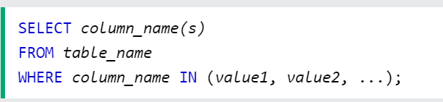

Q: I would like to know how many customer are there in Pune and Goa using the IN operator

A: SELECT * FROM Customer WHERE city IN ('Pune', 'Goa');

| customer_ID | LastName | FirstName | Address | City |
| --- | --- | --- | --- | --- |
| 10 | chilka | Dinesh | 305 - 14th Ave. S. Suite 3B | Pune |
| 20 | Ram | sham | Keskuskatu 45 | Mumbai |
| 10 | Manohar | Dasri | ul. Filtrowa 68 |  |
| 10 | Amit | Silam | gharkul Solapur | Pune |
| 50 | Wilman | Kala | Kanna chowk | Mumbai |

**Examples For Pr﻿actise**: : I would like to know how many customer are there they have customer_ID is 10 & 20 using the IN operator

NAme :Deepanshi

ANS: select * from customer where customer_ID in (10,20);

Select *from customer where Customer_ID in (10,20);

Answer Format 👍: Name: XYZ [Ans:]

Name: Mitali Gupta [Ans: Select * from customer where customer_ID in (10,20);]

Name Muskan Jain: select count (customer_id) from product where customer_id in (10,20)

Name : Ranjith Kumar [Ans: ] select * from Customer where customer_ID IN(‘10’,’20’);

NAME: Divya Jayakumar

ANS: [SELECT * FROM Customer WHERE City IN ('Pune', 'Goa');]

Name: shekalla venkata ashrith [ans:] SELECT *FROM Customer WHERE customer_ID IN (10,20);

Name : Shubham Kumar Vishwakarma [ select * from customer where customer_ID in (10,20); ]

Name: Hritam Roy : [ Select * from customer where customer_ID in (‘10’,’20’);]

Name : Sivasankaran S [ select * from customer where customer_ID in(10,20);]

Name: Prathamesh Rane [Ans]: select * from customer where customer_id in (10,20);

Name:Nandhini select * from customer where customer_id in(10,20);

Name:Nidhishree: select * from customer where customer_id IN (10,20);

Name:Ishant select * from customer where customer _id in (10,20);

Name : Likith (select * from customer where customer_id in (‘goa’,’pune’))

Name Vasanthakumar B Ans:select * from customer where city(‘Pune’,’Goa’);

Name Pramod: select * from customer where customer_ID in (10,20);

Name vasu tyagi[Ans:select*from customer where customer_id in(10,20)]

Name vivek [Ans: select * from customer where customer_id IN (10,20); ctrl+enter

Name = Nihal; ans = select * from customer where customer_id in (“10”,”20”); press ctrl + enter

Name: Diane Granger [Ans: SELECT * FROM customer WHERE customer_ID IN (10,20);]

# ORDER BY ASC/DESC

**The SQL ORDER BY Keyword**

The ORDER BY keyword is used to sort the result-set in ascending or descending order. The ORDER BY keyword sorts the records in ascending order by default. To sort the records in descending order, use the DESC keyword.

Q:"I have a requirement to display all “LastNames” from the customer table in ascending order using the ORDER BY clause."

A: select * from Customer order by LastName asc;

Name : Siva [ answer : select LastName from customer order by LastName asc;]

| customer_ID | LastName | FirstName | Address | City |
| --- | --- | --- | --- | --- |
| 10 | chilka | Dinesh | 305 - 14th Ave. S. Suite 3B | Pune |
| 20 | Ram | sham | Keskuskatu 45 | Mumbai |
| 10 | Manohar | Dasri | ul. Filtrowa 68 |  |
| 10 | Amit | Silam | gharkul Solapur | Mumbai |
| 50 | Wilman | Kala | Kanna chowk | Pune |

**Examples For Pr﻿actise**: :"I have a requirement to display all cities from the customer table in descending order using the ORDER BY clause."

**NAme :Deepanshi**

**ANS: select city from customer order by city desc;**

Lahari: Select * from customer order by City desc;

Answer Format 👍: Name: XYZ [Ans: ]

Name: Mitali Gupta [Ans: Select city from customer ORDER BY city desc;]

Name: kaustubh… select * from Customer order by city desc;

Name Muskan Jain: select city from customer order by city desc;

NAME:Ranjith Kumar [select * from customer order by city desc;]

NAME: Divya Jayakumar

ANS: [Select LastName From Customer Order by LastName ASC;]

Name: venkata ashrith [ans:] SELECT * FROM Customer ORDER BY City DESC;

Name: Prathamesh Rane [Ans]:select City from customer order by desc; / select * from customer order by city desc;

Name : Shubham Kumar Vishwakarma [ select * from customer order by city desc; ]

Name : Hritam Roy:- [ Select * from customer where order by city desc;]

Name :vasu tyagi[Ans:select *from customer order by city descname]

Name Vasanthakumar B Ans:select * customer order by city asc;/ select * from customer order by city desc;

Name : Likith (select * from customer order by city desc)

Name: Nandhini select city from customer order by city desc

Name :Ishant select * from order by city desc;

Name pramod :select * from customer order by city desc;

Name: NIdhishree: select * from customer order by city desc;

Name: mayank select * from order by city desc FirstName;

Name: Nihal Thakur ans.. Select * from customer order by LastName asc;

Name :narsimha:select * from customer order naby city asc;

Tarun [Select* from customer order by LastName asc;

Select * From Customer Order by LastName desc;

Select * from Customer order by Customer_id asc;]

Name:narsimha:select * from custemer order by city desc

Name: Diane Granger [Ans: SELECT * FROM customer ORDER BY city DESC;]

Name: Nihal Thakur -> select * from customer order by city desc;

Name: Siddul Ashwini : select * from customer order by LastName asc;

# SQL NULL Values

What is a NULL Value?

A field with a NULL value is a field with no value.

If a field in a table is optional, it is possible to insert a new record or update a record without adding a value to this field. Then, the field will be saved with a NULL value. We will have to use the IS NULL and IS NOT NULL operators instead.

Q: I have a requirement to display Null Values in Tables

A: Select * From Customer Where City IS Null;

| customer_ID | LastName | FirstName | Address | City |
| --- | --- | --- | --- | --- |
| 10 | chilka | Dinesh | 305 - 14th Ave. S. Suite 3B | Pune |
| 20 | Ram | sham | Keskuskatu 45 | Mumbai |
| 10 | Manohar | Dasri | ul. Filtrowa 68 |  |
| 10 | Amit | Silam | gharkul Solapur | Pune |
| 50 | Wilman | Kala | Kanna chowk | Mumbai |

Name: Mitali Gupta [Ans: select * from customer where city is Null;]

Name Muskan Jain: select *from customer where city is null;

Select *from customer wher City IS Null;

Name: kaustubh….. select*from customer Where city is Null;

NAME: Divya Jayakumar

ANS:(Select * From Customer Where City IS Null;)

Name:Ranjith Kumar[select * from customer where city is null;]

Name: venkata ashrith [ans:] SELECT * FROM customer WHERE CITY IS NULL;

Name: Prathamesh Rane [Ans]: select * from customer where city is NULL;

Name : Hritam Roy :- [ Select * from customer where city is NULL;]

Name; Vasanthakumar B [Ans] select * from customer where city is null; / select * from customer where city is not null;

Name :vasu tyagi[Ans:select*from customer where city is NULL]

Name: Nandhini select * from customer where city is null

Name: Ishant [Ans] select * from customer where City =Null;

Name :mayank [Ans] select * from customer where city = null;

Tarun [Select * from customer where city is Null;]

Name: Likith (select * from customer where city=’null’)

Name snehal : select * from customer where city = null;

Name: Diane Granger [Ans: SELECT * FROM customer WHERE city is NULL;]

Name : narsimha :select * from customer where city = null;

Name: bhavesh :select * from customer where Lastname=null;

Name:Nidhishree: select * from customer where city=null;

select last name as first name as last name from customer;

# Top ﻿/Limit

The SQL SELECT LIMIT Clause

The SELECT TOP clause is used to specify the number of records to return. The SELECT TOP clause is useful on large tables with thousands of records. Returning a large number of records can impact performance.

I can specify Limits of records inTable How Many Records I want look

Q: I have a requirement to display FIrst 2 records customer Table.

A: SELECT * FROM Customer Limit 2;

| customer_ID | LastName | FirstName | Address | City |
| --- | --- | --- | --- | --- |
| 10 | chilka | Dinesh | 305 - 14th Ave. S. Suite 3B | Pune |
| 20 | Ram | sham | Keskuskatu 45 | Mumbai |
| 10 | Manohar | Dasri | ul. Filtrowa 68 |  |
| 10 | Amit | Silam | gharkul Solapur | Pune |
| 50 | Wilman | Kala | Kanna chowk | Mumbai |

**Examples For Pr﻿practice**:: I have a requirement to display FIrst 4 reorords customer Table.

NAme: Deepanshi

ANS: select * from customers limit 4;

Answer Format 👍: Name: XYZ [Ans: ] Name

Name: Mitali Gupta [Ans: selet * from customer limit 4;]

Name: Prathamesh Rane [Ans]: select * from customer limit 2

Name:Kaustubh… select*from customer limit 4;

Name Muskan Jain [Ans: select * from customer limit 4; ]

Name :Ranjith Kumar[select * from customer Limit 4;]

Name: venkata ashrith [ans:] SELECT * FROM Customer LIMIT 4;

Name : DIvya Jayakumar

ANS: [Select Top 2 * From Customer;

Select * From Customer LIMIT 2;]

;

Name : Shubham Kumar Vishwakarma [ select * from customer limit 4; ]

Name - Hritam Roy:- [Select * from Customer limit4;]

Name:vasu tyagi[Ans:select *from customer limit 4;]

Name:Ishant [Ans] select * from customer limit 2;

Name:mayank[ans] select * from customer limit 2;

Name: Likith (select * from customer Limit 4)

Name:Nandhini select * from customer limit 4;

Name:Vasanthakumar B[ans] select * from customer limit 4;

name : narsimha : select * from customer limit 4:

Name: Diane Granger [Ans: SELECT * FROM customer LIMIT 4;]

Name snehal ; select * from customer limit 3;

Name : Nihal -> select * from customer limit 2;

Name: bhavesh

Name:Nidhishree: select * from customers limit 4;

# SQL UPDATE Statement

The UPDATE statement is used to modify the existing records in a table.

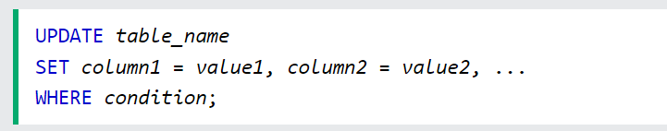

Q: I need to change the First name 'Dinesh' to 'ElonMusk' in the customer table using Update

A: update Customer set FirstName='ElonMusk' where customer_ID='20';

| customer_ID | LastName | FirstName | Address | City |
| --- | --- | --- | --- | --- |
| 10 | chilka | Dinesh | 305 - 14th Ave. S. Suite 3B | Pune |
| 20 | Ram | sham | Keskuskatu 45 | Mumbai |
| 10 | Manohar | Dasri | ul. Filtrowa 68 |  |
| 10 | Amit | Silam | gharkul Solapur | Pune |
| 50 | Wilman | Kala | Kanna chowk | Mumbai |

**Examples For Pr﻿actise**: :I want to update the city ‘Goa’ where FirstName is Dasri using update command

Answer Format 👍: Name: XYZ [Ans: ]

NAme: Deepanshi:

ANS: Update customer set city = ‘GOA’ where firstname = ‘Dasri’;

Name: Mitali Gupta [Ans: Update customer set city='Goa' where FirstName= 'Dasri';]

Name: Kaustubh…. Update customer set city=’Goa’ where FirstName=’Dasri’;

Name: Prathamesh Rane [Ans]:update customer set FirstName=’ElonMusk” where FirstName=’Dinesh’;

Name:Ranjith Kumar[update customer set city=’Goa’ where FirstName=’Dasri’;]

Name: venkata ashrith [ans:] UPDATE Customer SET City =’Goa’ WHERE FirstName=’Dasari’;

Name:vasu tyagi[ans:update customer set city=’Goa’ where firstname=’Dasri’]

Name: Nandhini update customer set city=’Goa’ where FirstName=’Dasri’;

Name : Shubham Kumar Vishwakarma [ Update customer set city=’Goa’ where Firstname=’Dasri’; ]

Name : Divya Jayakumar

ANS:[Update Customer Set FirstName = 'ElonMusk' Where FirstName = ‘Dinesh’ ]

Name : Hritam Roy:- [Update customer set City=’Goa’ where FirstName=’Dasri’;]

Name: Ishant [Ans]Update customer set FirstName='ElonMusk' where customer_ID='20';

Name: mayank [ans] Update customer set FirstName='ElonMusk' where customer_ID='20';

Name: Nidhishree: Update customer set City=’Goa’ where Firstname=’Dasri’;

Name : Likith (update customer set city=’Goa’ where FirstName=’Dasri’)

Name Vasanthakumar B[ans] update customer set=’Goa’ where FirstName=’Dasri’;

Name pramod: update customer set city=’goa; where FirstName=’dasri’;

Name: Diane Granger [Ans: UPDATE customer SET city="Goa" WHERE FirstName='Dasri';]

Name :narsimha :update customer set lastname=’arun’ where firstname=’allu’;

**Examples For Pr﻿actise**: I need to change the LastName ‘Ram’ to ‘Yash’ in the customer table using Update command

Answer Format 👍: Name: XYZ [Ans: ]

Name: Mitali Gupta [Ans: Update customer set LastName='Yash' where LastName='Ram';]

Name:Ranjith Kumar[update customer set LastName=’Yash’ where LastName=’Ram’;]

Name: Prathamesh Rane [Ans]: update customer set LastName=”Yash” where LastName=”Ram”;

Name:Kaustubh….. Update customer set LastName=’Yash’ where LastName=’Ram’;

Name Pramod: update customer set LastName=’yash’ where LastName=’Ram’;

Name Muskan Jain: update Customer set lastName='yash' where lastname = 'ram';

Name:Nandhini update customer set lastName=’Yash’ where lastName=’Ram’;

Name: Venkata Ashrith [ans:] UPDATE Customer SET LastName=’Yash’ WHERE LastName=’Ram’;

Name Vasanthakumar B[ans] update customer set LastName=’Yash’ where LastName=’Ram’;

Name: Diane Granger [Ans: UPDATE customer SET LastName='Yash' WHERE LastName='Ram';]

Name:Nidhishree: Update customer set Lastname=’Yash’ where Lastname=’Ram’;

# SQL DELETE Statement

The DELETE statement is used to delete existing records in a table.



Q:I want to delete LastName 'Amit' in customer Table

A: DELETE FROM Customer WHERE LastName='Amit';

| customer_ID | LastName | FirstName | Address | City |
| --- | --- | --- | --- | --- |
| 10 | chilka | Dinesh | 305 - 14th Ave. S. Suite 3B | Pune |
| 20 | Ram | sham | Keskuskatu 45 | Mumbai |
| 10 | Manohar | Dasri | ul. Filtrowa 68 |  |
| 10 | Amit | Silam | gharkul Solapur | Pune |
| 50 | Wilman | Kala | Kanna chowk | Mumbai |

**Examples For Pr﻿actise**: I want to delete FirstName 'kala' in customer Table

Name: Deepanshi

ANs: [Delete from customer where firstname = ‘Kala’;]

Name: Mitali Gupta [Ans: delete from customer where FirstName='kala';]

Name: Kaustubh… delete from customer where FirstName=’kala’;

Name: Prathamesh Rane [Ans]: delete from customer where FirstName=’Kala’;

Name: Nandhini delete from customer where FirstName=’kala’;

Name Muskan Jain: delete from customer where firstname= 'kala' ;

Name vasu tyagi[ans:delete from customer where FirstName=’kala’’]

Name: Ranjith Kumar [delete from customer where FirstName=’Kala’;]

Name: Venkata Ashrith [ans:] DELETE FROM Customer WHERE LastName=’Kala’;

Name : Hritam Roy:- [ Delete from Customer where FirstName=’kala’;]

Name : Shubham Kumar Vishwakarma [ delete from customer where firstname=’Kala’; ]

NAME: Divya Jayakumar

ANS: [Delete From Customer Where LastName = ‘Amit’]

Name: Ishant [Ans] Delete from customer WHERE LastName='Amit';

Name: Mayank [Ans] delete from customer where LastName=”Amit”;

Name Vasanthakumar B [ans] delete from customer where FirstName=’kala’;

Name : Likith (Delete from customer where FirstName=’kala’)

Name: Prathamesh Rane [Ans]: delete from customer where FirstName=’Kala’;

Name: Venkata Ashrith [ans:] DELETE FROM Customer WHERE LastName=’Kala’;

Name pramod: delete from customer where customer LastName=’kala’;

Name: Nidhishree: delete from customer where customer Firstname=’kala’;

Name snehal: delete from cus

Name: bhavesh:delete from customer where lastname='mane';tomer where customer LastName = ‘Ram’;

Name snehal : delete form customer where customer FirstName = ‘Sham’;

Name: Diane Granger [Ans: DELETE FROM customer WHERE FirstName='kala';]

Name :narsimha :delete from customer where lastname=kala;

DELETE from customer where lastname=’kala’;

# SQL Aliases

SQL aliases are used to give a table, or a column in a table, a temporary name.

Aliases are often used to make column names more readable.

An alias only exists for the duration of that query.

An alias is created with the AS keyword.

Q: I would like to change the column names

in the customer table. Specifically, I want to rename the "LastName" column to "FirstName", and the "FirstName" column to "LastName" using Aliases

A: SELECT LastName AS FirstName, FirstName AS LastName FROM Customer;

| customer_ID | LastName | FirstName | Address | City |
| --- | --- | --- | --- | --- |
| 10 | chilka | Dinesh | 305 - 14th Ave. S. Suite 3B | Pune |
| 20 | Ram | sham | Keskuskatu 45 | Mumbai |
| 10 | Manohar | Dasri | ul. Filtrowa 68 |  |
| 10 | Amit | Silam | gharkul Solapur | Pune |
| 50 | Wilman | Kala | Kanna chowk | Mumbai |

**Examples For Pr﻿a ctise**: I want to change the column name in the customer table. Specifically, I want to rename "customer_ID" to "ID" using aliases.

Answer Format 👍: Name: xyz [Ans: ]

NAme: Deepanshi

ANS: [Select customer_ID as ID from customers;]

Name: Mitali Gupta [Ans: Select customer_ID as ID from customer;]

Name : Shubham Kumar Vishwakarma [ select customer_ID as ID from Customer; ]

Name snehal Bhilare [select customer_ID as ID form customer;]

Name : Ishant [Ans]SELECT LastName AS FirstName, FirstName AS LastName FROM Customer;

Name: Mayank[ans] SELECT LastName AS FirstName, FirstName AS LastName FROM Customer;

Name :Ranjith Kumar[select customer_ID as ID from customer;]

Name Vasanthakumar B [Ans] select customer_id as id from customer;

Name tarun [select FirstName as lastName ,lastName as FirstName from customer]

Name vasu tyagi[ans:select firstname as lastname,lastname as firstname from customer]

Name : Divya Jayakumar

ANS: [Select FirstName as LastName, LastName as FirstName From Customer;]

Name: Likith (select customer_ID as ID from customer)

Name: Diane Granger [Ans: SELECT customer_ID as ID FROM customer;]

Name: Nandhini [Ans: select customer_id as id from customer;]

# SQL Comments

Single-line comments start with --.

Any text between -- and the end of the line will be ignored (will not be executed)

We can use a line comment to prevent the execution of a query that has been mistakenly included in the code. This way, instead of removing the query, we can simply comment it out using a single line of code.



# 

# 

# 

# 

# NamThe SQL MIN() and MAX() Functions

The MIN() function returns the smallest value of the selected column.

The MAX() function returns the largest value of the selected column.

Q: I want to know whats is minimum price in Product table

A: select min(Price) from products;

Table name:products

| Product_Id | Product_Name | Supplier_Id | category_ID | Unit | Price |
| --- | --- | --- | --- | --- | --- |
| 1 | Chais | 1 | 1 | 10 boxes x 20 bags | 18 |
| 2 | Chang | 1 | 1 | 24 - 12 oz bottles | 19 |
| 3 | Aniseed Syrup | 1 | 2 | 12 - 550 ml bottles | 10 |
| 4 | Chef Anton's Cajun Seasoning | 2 | 2 | 48 - 6 oz jars | 22 |
| 5 | Chef Anton's Gumbo 0Mix | 2 | 2 | 36 boxes | 21.35 |
| 6 | Grandma's Boysenberry Spread | 3 | 2 | 12 - 8 oz jars | 25 |
| 7 | Uncle Bob's Organic Dried Pears | 3 | 7 | 12 - 1 lb pkgs. | 30 |
| 8 | Northwoods Cranberry Sauce | 3 | 2 | 12 - 12 oz jars | 40 |
| 9 | Mishi Kobe Niku | 4 | 6 | 18 - 500 g pkgs. | 97 |
| 10 | Ikura | 4 | 8 | 12 - 200 ml jars | 31 |

**Examples For Pr﻿actise**: I want to know what is the Maximum Price in Product table.

Answer Format 👍: Name: xyz [ Ans: ]

NAme: Deepanshi

ANS: [select max(price) from product;]

Name: Mitali Gupta [Ans: select max(price) from product;]

Name: Nandhini [Ans: select max(price) from product;}

Name Vasanthakumar B [ans] select max(price) from product;

Name:Ranith Kumar [select max(price) from product;]

Name vasu tyagi[ans:select max(price)from product]

Name Tarun[select min(price) from product;][select max(price) from product;]

Name : Likith (select max(price) from product)

Name : Shubham Kumar Vishwakarma [ select max(price) from product; ]

Name: Rishika  
[Ans] SELECT MAX(price) FROM products;

Name: bhavesh: select min(Price) from products;

Name Snehal Bhilare [ select min(price) from product;]

Name Snehal Bhilare [ select max(price) from product;]

Name: Nandhini [Ans: select min(price) from product;]

Name: Diane Granger [Ans: SELECT MAX(Price) FROM products;]

Name: Mayank[Ans] select max(price) from product;Name: Divya Jayakumar

ANS: [Select MIN(Price) From Products;]

[Select MAX(Price) From Products;]

Name PRAVEEN

SELECT MIN(PRICE)FROM PRODUCT;

SELECT MAX(PRICE)FROM PRODUCT;

Name : Ishant

Select min(Price) from products;

Select max(Price) from products;

# SQL COUNT(), AVG() and SUM() Functions

The COUNT() function returns the number of rows that matches a specified criterion.

The AVG() function returns the average value of a numeric column.

The SUM() function returns the total sum of a numeric column.

Q: I want to know what is the total of price?

A: select sum(Price) from products;

Q: I want to know what is the Avg of price?

A:select avg(Price) from products;

| Product_Id | Product_Name | Supplier_Id | category_ID | Unit | Price |
| --- | --- | --- | --- | --- | --- |
| 1 | Chais | 1 | 1 | 10 boxes x 20 bags | 18 |
| 2 | Chang | 1 | 1 | 24 - 12 oz bottles | 19 |
| 3 | Aniseed Syrup | 1 | 2 | 12 - 550 ml bottles | 10 |
| 4 | Chef Anton's Cajun Seasoning | 2 | 2 | 48 - 6 oz jars | 22 |
| 5 | Chef Anton's Gumbo Mix | 2 | 2 | 36 boxes | 21.35 |
| 6 | Grandma's Boysenberry Spread | 3 | 2 | 12 - 8 oz jars | 25 |
| 7 | Uncle Bob's Organic Dried Pears | 3 | 7 | 12 - 1 lb pkgs. | 30 |
| 8 | Northwoods Cranberry Sauce | 3 | 2 | 12 - 12 oz jars | 40 |
| 9 | Mishi Kobe Niku | 4 | 6 | 18 - 500 g pkgs. | 97 |
| 10 | Ikura | 4 | 8 | 12 - 200 ml jars | 31 |

**Examples For Pr﻿actise**: : I want to know how many records are there in the price column.

Answer Format 👍: Name: xyz [ Ans: ]

Name: Mitali Gupta [Ans: select count(Price) from products;]

Name: Rishika

[Ans] SELECT COUNT(Price) FROM products;

Name: Divya Jyakumar

ANS: [Select Sum(Price) From Product;]

[Select Avg(Price) From Product;]

Name vasu tyagi [ans:select count(price)from product]

**Name : Deepanshi-**

**ANS = [select count(price) from product]**

Name:Ranjith Kumar[select count(price) from product;]

Name:Ranjith Kumar[select sum(price) from product;]

Name:Ranjith Kumar[select avg(price) from product;]

Name: Nandhini [Ans: select sum(price) from product;]

Name Snehal Bhilare [ select sum(price) from product;]

Name: Likith (select count(price) from product)

Name bhavesh:select count (price) from product;

Name Vasanthakumar B[ans] select count(price),avg(price),sum(price) from products;

Name : Ishant select count(price) from products;

Select sum(price) from products;

Select avg(price) from products;

Name: Mayank [Ans]

select count(price) from product ;

select sum(price) from product ;

select avg(price) from product ;

Name :Tarun [select sum(price) from product; select avg(price) from product;

select count(price) from product;]

Name snehal Bhilare [ select avg(price) from product;]

Name snehal Bhilare [ select count(price) from product;]

Name : Shubham Kumar Vishwakamra [ select count(price) from product; ]

Name :narsimha :[select count(price) from

product;]

Name :narsimha :[select max(price) from product;]

Name: Diane Granger [Ans: SELECT COUNT(Price) FROM products;]

Name:Ayush Shende “select count(price) from product”

Name:Ayush Shende “select avg(price) from product”

Name:Ayush Shende “select min(price) from product”

Name:Ayush Shende “select max(price) from product”

Name: Deepak Malkari “select max(price) from product”

Praveen Bhise

SELECT AVG(PRICE) from Product;

SELECT SUM(PRICE) from Product;

SELECT Count (PRICE) from Product;

Siddul Ashwini: select count(price) from products;

select avg(price) from products;

select sum(price) from products;

# SQL JOIN’S - INNER JOIN

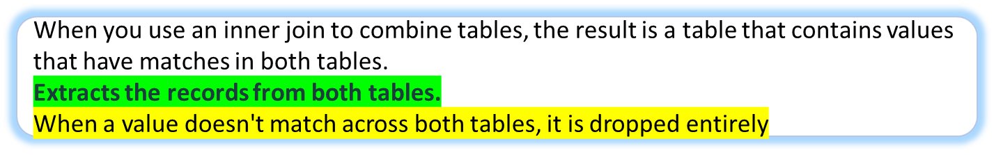

A JOIN clause is used to combine rows from two or more tables, based on a related column between them.

The INNER JOIN keyword selects records that have matching values in both tables.

* (INNER) JOIN: Returns records that have matching values in both tables

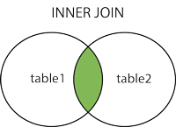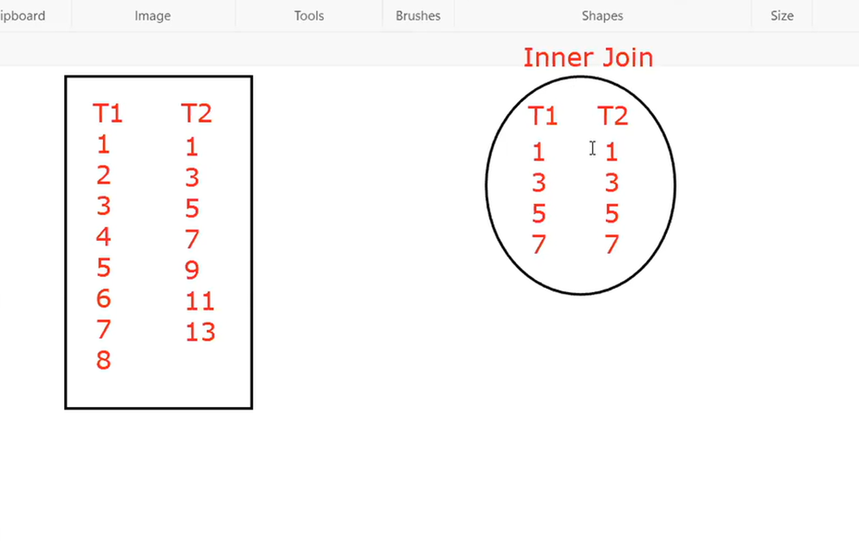

**INNER JOIN Syntax**

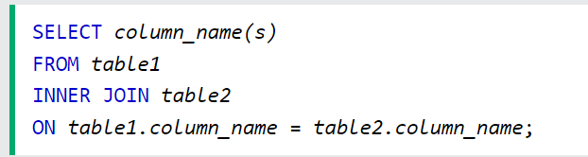

Table Name: country

| **country_id** | **country_Name** |
| --- | --- |
| 1 | India |
| 2 | Nepal |
| 2 | Srilanka |

# 

Table Name: State

| **state_Id** | **country_id** | **state_Name** |
| --- | --- | --- |
| 3 | 2 | Pune |
| 4 | 4 | california |
| 4 | 10 | Kathmandu |
| 1 | 1 | Maharashtra |
| 2 | 1 | Punjab |

Q:"I have noticed that both the 'country' and 'state' tables contain a column called 'country_id' and they are related to each other. My objective is to combine these tables using the 'country_id' column and display selects records that have matching values in both tables.

Ans: **select * from country inner join state on country.country_id=state.country_id;**

Result: Inner Join

| country_id | country_Name | state_Id | country_id | state_Name |
| --- | --- | --- | --- | --- |
| 2 | Srilanka | 3 | 2 | Pune |
| 2 | Nepal | 3 | 2 | Pune |
| 1 | India | 1 | 1 | Maharashtra |
| 1 | India | 2 | 1 | Punjab |

**Examples For Pr﻿actise**:

Q:Try To perform Inner Joints In Given Tables and Write Query.

**HINT** : "I have noticed that both the customer’ and 'Person’' tables contain a column called “**cutomer_id”**  and they are related to each other.

Table Name: customer

| **cutomer_id** | **customer_name** |
| --- | --- |
| 1 | Dinesh chilka |
| 1 | Amit silam |
| 2 | Manohar Dasri |

# 

Table Name: Person

| **ContactName** | **cutomer_id** | **city** |
| --- | --- | --- |
| JOHN | 1 | Pune |
| SWEETY | 4 | california |
| LOVELY | 10 | Kathmandu |
| Andrew | 1 | Maharashtra |
| Michael | 1 | Punjab |

Answer Format 👍: Name: xyz [ Ans: ]

Name: Mitali Gupta [Ans:Select * from customer c inner join person p ON c.customer_id =p.customer_id;]

Name: Rishika  
[Ans] SELECT * FROM customer INNER JOIN person ON customer.customer_id=person.customer_id;

Name: Deepanshi

ANS - **[Select * from customer c**

**Inner join person p on c.cutomer_id = p.cutomer_id]**

NAME: Divya Jayakumar

ANS: [Select * From Customer c Inner Join Person p ON c.customer_id = p.customer_id;]

Name vasu tyagi [ans:select from customer as c inner join person as p on c.customer_id=p.customer_id]

Name: Prathamesh Rane [ans]: select * from customer c join person p on c.customer_id=p.customer_id;

Name: Deepanshi

ANS - **[Select * from customer c**

**Inner join person p on c.cutomer_id = p.cutomer_id]**

Name:Ranjith Kumar

Ans:[Select * from customer c inner join person p on c.customer_id = p.customer_id;]

Name Vasanthakumar B [ans] select * from customer inner join customer on customer.customer_id=person.customer_id;

Praveen Bhise

SELECT * from customer c

join person p

on c.customer_id= p.Customer_id;

Name: Nandhini [Ans: select * from customer inner join person on customer.customerid=person.customerid;]

Name : Shubham Kumar Vishwakarma [ select * from customer c inner join Person p on c.customer_id=p.customer_id; ]

Name: Tarun [select * from customer c inner joint person p on c.customer_id=p.customer_id]

Name ajay :: Select * from customer inner join person on customer.customer_id=person.customer_id;

Name : Ishant select * from customer inner join person on customer.customer_id=person.customer_id ;

Name :Mayank[ans]

select * from customer inner join person on customer.customer_id= person.customer_id;

# SQL LEFT JOIN

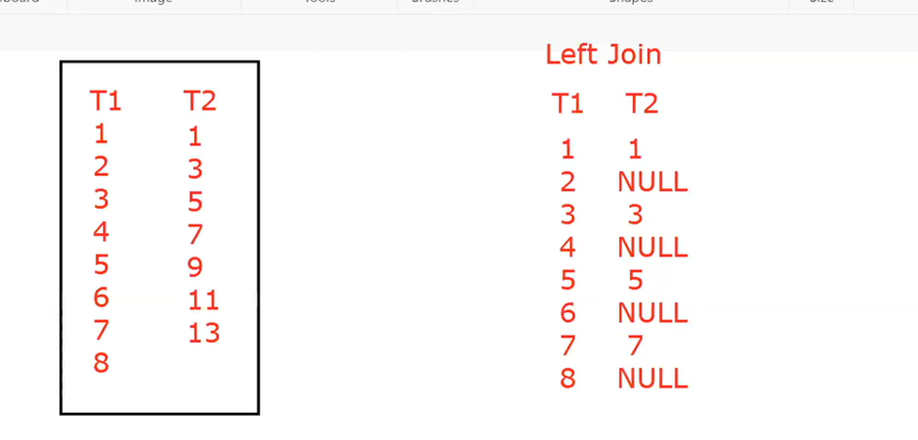

Table Name: country

| **country_id** | **country_Name** |
| --- | --- |
| 1 | India |
| 2 | Nepal |
| 2 | Srilanka |

# 

Table Name: State

| **state_Id** | **country_id** | **state_Name** |
| --- | --- | --- |
| 3 | 2 | Pune |
| 4 | 4 | california |
| 4 | 10 | Kathmandu |
| 1 | 1 | Maharashtra |
| 2 | 1 | Punjab |

Q: "I have noticed that both the 'country' and 'state' tables contain a column called 'country_id' and they are related to each other. My objective is to combine these tables using the 'country_id' column and display returns all records from the left table (table1), and the matching records from the right table (table2)."

Ans: **select** * **from** country **left join** state **on** country**.**country_id**=**state**.**country_id;

Result Left Join

| country_id | country_Name | state_Id | country_id | state_Name |
| --- | --- | --- | --- | --- |
| 1 | India | 2 | 1 | Punjab |
| 1 | India | 1 | 1 | Maharashtra |
| 2 | Nepal | 3 | 2 | Pune |
| 2 | Srilanka | 3 | 2 | Pune |

**Examples For Pr﻿actise**:

Q:Try To perform Left Joints In Given Tables and returns all records from the left table (table1), and the matching records from the right table (table2).

**HINT** : "I have noticed that both the customer’ and 'Person’' tables contain a column called “**cutomer_id”**  and they are related to each other.

Table Name: customer

| **cutomer_id** | **customer_name** |
| --- | --- |
| 1 | Dinesh chilka |
| 1 | Amit silam |
| 2 | Manohar Dasri |

# 

Table Name: Person

| **ContactName** | **cutomer_id** | **city** |
| --- | --- | --- |
| JOHN | 1 | Pune |
| SWEETY | 4 | california |
| LOVELY | 10 | Kathmandu |
| Andrew | 1 | Maharashtra |
| Michael | 1 | Punjab |

Answer Format 👍: Name: xyz [ Ans]

**Name: Rishika, Ans:**

**SELECT * FROM customer LEFT JOIN person ON customer.customer_id=person.customer_id;**

**Name vasu tyagi [ans:select* from customer left join person on customer_customer_id=person.customer_id]**

Name: Mitali Gupta [ans: select * from customer c left join person p ON c.customer_ID=p.customer_id;]

Name: Deepanshi

ANS: **[select * from customer c**

**Left join person p on c.cutomer_id = p.cutomer_id]**

**Name vasu tyagi[ans:select* from customer left join person on customer_customer_id=person.customer_id]**

Name Vasanthakumar B[ans] select * frome customer c left join person p on c.customer_id=p.customer_id;

Name: Deepanshi

ANS: **[select * from customer c**

**Left join person p on c.cutomer_id = p.cutomer_id]**

Name: Deepanshi

ANS: **[select * from customer c**

**Left join person p on c.cutomer_id = p.cutomer_id]**

NAME: Divya Jayakumar

ANS: [Select * From Customer c Left Join Person p ON c.customer_id = p.customer_id;]

Name: Deepanshi

ANS: **[select * from customer c**

**Left join person p on c.cutomer_id = p.cutomer_id]**

Name: Prathamesh Rane [ans]: select * from customer c left join person on c.customer_id=p.customer_id;

# 

# 

# 

# 

# 

# 

# 

# 

# 

# 

# 

# 

# 

# 

# 

# 

# 

# 

# 

# 

# 

# 

# 

# 

# 

# 

# 

# 

# 

# 

# 

# 

# 

# 

# 

# 

# 

# 

# 

# 

# 

# 

# 

# 

# 

# 

# 

# 

# 

# 

# 

# 

# SQL RIGHT JOIN

The RIGHT JOIN keyword returns all records from the right table (table2), and the matching records from the left table (table1). The result is 0 records from the left side, if there is no match.

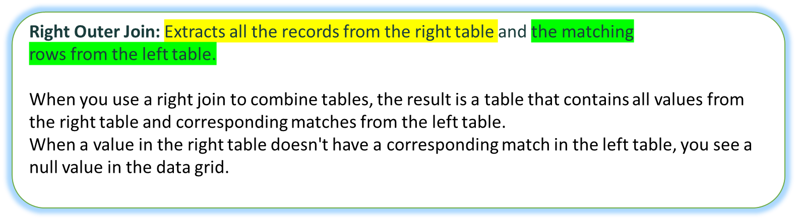

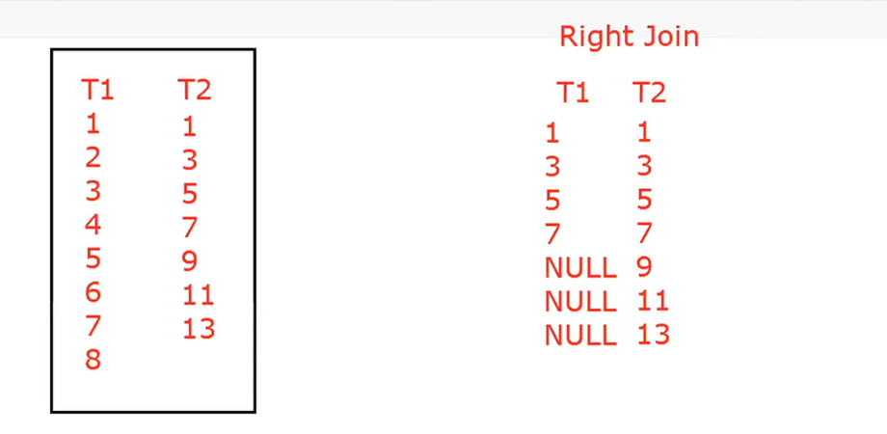

# 

Table Name: country

| **country_id** | **country_Name** |
| --- | --- |
| 1 | India |
| 2 | Nepal |
| 2 | Srilanka |

# 

Table Name: State

| **state_Id** | **country_id** | **state_Name** |
| --- | --- | --- |
| 3 | 2 | Pune |
| 4 | 4 | california |
| 4 | 10 | Kathmandu |
| 1 | 1 | Maharashtra |
| 2 | 1 | Punjab |

Q:"I have noticed that both the 'country' and 'state' tables contain a column called 'country_id' and they are related to each other. My objective is to combine these tables using the 'country_id' column and display returns all records from the right table (table2), and the matching records from the left table (table1)

A: select * from country right join state on country.country_id=state.country_id;

Result: Right Join

| country_id | country_Name | state_Id | country_id | state_Name |
| --- | --- | --- | --- | --- |
| 2 | Srilanka | 3 | 2 | Pune |
| 2 | Nepal | 3 | 2 | Pune |
| Null | Null | 4 | 4 | california |
| Null | Null | 4 | 10 | Kathmandu |
| 1 | India | 1 | 1 | Maharashtra |
| 1 | India | 2 | 1 | Punjab |
| Null | Null | 3 | 3 | Mumbai |
| Null | Null | 4 | 4 | california |

**Examples For Pr﻿actise**:

Q:Try To perform right Joints In Given Tables and returns all records from the right table (table2), and the matching records from the left table (table1). The result is 0 records from the left side, if there is no match.

**HINT** : "I have noticed that both the customer’ and 'Person’' tables contain a column called “**cutomer_id”**  and they are related to each other.

Table Name: customer

| **cutomer_id** | **customer_name** |
| --- | --- |
| 1 | Dinesh chilka |
| 1 | Amit silam |
| 2 | Manohar Dasri |

# 

Table Name: Person

| **ContactName** | **cutomer_id** | **city** |
| --- | --- | --- |
| JOHN | 1 | Pune |
| SWEETY | 4 | california |
| LOVELY | 10 | Kathmandu |
| Andrew | 1 | Maharashtra |
| Michael | 1 | Punjab |

Answer Format 👍: Name: xyz [ Ans: ]

Name: Mitali Gupta [Ans: select * from customer c right join person p ON c.customer_id=p.customer_id;]

NAME: Divya Jayakumar

ANS: [Select * From Customer c Right Join Person p ON c.customer_id = p.customer_id;]

Name: Deepanshi

ANS: **[select * from customer c**

**Right join person p on c.cutomer_id = p.cutomer_id]**

Name: Prathamesh Rane [ans]: select * from customer c right join person on c.customer_id=p.customer_id;

# 

# 

# 

# 

# 

# 

# 

# 

# 

# 

# 

# 

# 

# 

# 

# 

# 

# 

# 

# 

# 

# 

# 

# 

# 

# 

# 

# 

# 

# 

# 

# 

# 

# 

# 

# 

# 

# 

# 

# 

# 

# 

# 

# 

# 

# 

# 

# 

# 

# 

# 

# 

# 

# 

# 

# 

# 

# 

# 

# 

# 

# 

# 

# 

# 

# 

# 

# 

# 

# 

# 

# 

# 

# 

# 

# 

# 

# 

# 

# 

# 

# 

# 

# 

# 

# 

# 

# 

# 

# 

# 

# 

# 

# 

# 

# 

# 

# 

# 

# 

# 

# 

# 

# 

# 

# 

# 

# 

# 

# 

# 

# 

# 

# 

# 

# 

# 

# 

# 

# 

# 

# 

# SQL FULL OUTER JOIN

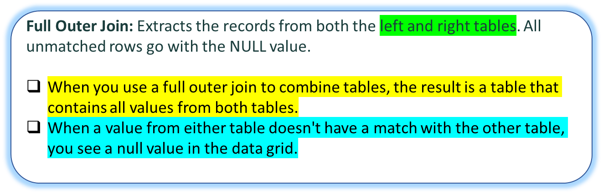

The FULL OUTER JOIN keyword returns all records when there is a match in left (table1) or right (table2) table records.

Tip: FULL OUTER JOIN and FULL JOIN are the same.

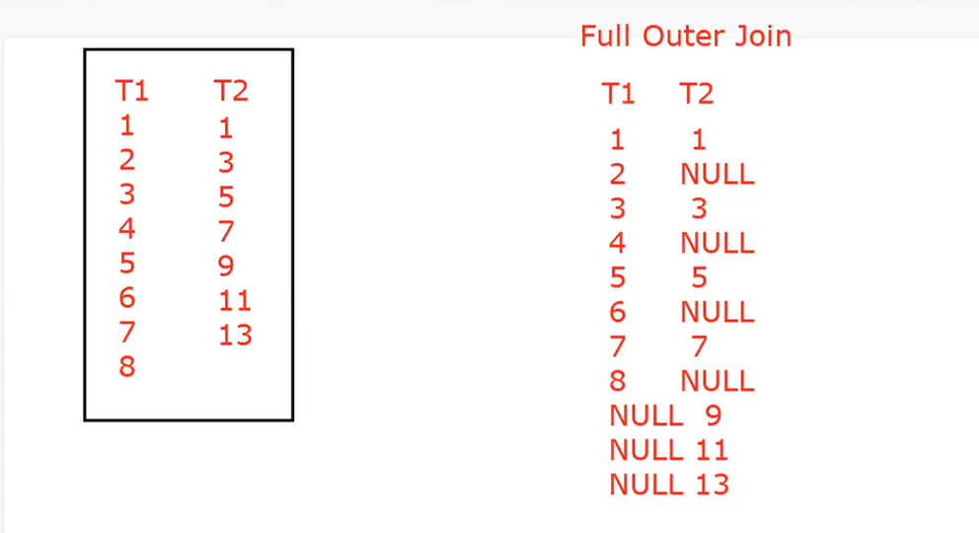

# 

Table Name: country

| **country_id** | **country_Name** |
| --- | --- |
| 1 | India |
| 2 | Nepal |
| 2 | Srilanka |

# 

Table Name: State

| **state_Id** | **country_id** | **state_Name** |
| --- | --- | --- |
| 3 | 2 | Pune |
| 4 | 4 | california |
| 4 | 10 | Kathmandu |
| 1 | 1 | Maharashtra |
| 2 | 1 | Punjab |

Q:"I have noticed that both the 'country' and 'state' tables contain a column called 'country_id' and they are related to each other. My objective is to combine these tables using the 'country_id' column and display all records when there is a match in left (table1) or right (table2) table records.

A: select * from country full outer join state on country.country_id=state.country_id;

**Examples For Pr﻿actise**:

Q:Try To perform Full outer Joints In Given Tables and display all records from both the left and right tables.

**HINT** : "I have noticed that both the customer’ and 'Person’' tables contain a column called “**cutomer_id”**  and they are related to each other.

Table Name: customer

| **cutomer_id** | **customer_name** |
| --- | --- |
| 1 | Dinesh chilka |
| 1 | Amit silam |
| 2 | Manohar Dasri |

# 

Table Name: Person

| **ContactName** | **cutomer_id** | **city** |
| --- | --- | --- |
| JOHN | 1 | Pune |
| SWEETY | 4 | california |
| LOVELY | 10 | Kathmandu |
| Andrew | 1 | Maharashtra |
| Michael | 1 | Punjab |

Answer Format 👍: Name: xyz [ Ans: ]

NAME: Divya Jayakumar

ANS: [Select * From Customer c Full Join Person p ON c.customer_id = p.customer_id;]

Name: Mitali Gupta [ans: select * from customer c full join person p ON c.customer_id=p.customer_id;]

NAME: Divya Jayakumar

ANS: [Select * From Customer c Full Join Person p ON c.customer_id = p.customer_id;]

Name: Deepanshi

ANS: **[select * from customer c**

**full join person p on c.cutomer_id = p.cutomer_id]**

Name: Prathamesh Rane [ans]: select * from customer c full join person on c.customer_id=p.customer_id;

# Day 4- Assignment

Q: Retrieve all unique values of the "category" column from the "products" table.Suppose you have a "products" table with the following data:

Table Name: products

| product_id | product_name | category | price |
| --- | --- | --- | --- |
| 1 | T-Shirt | Clothing | 10.99 |
| 2 | Socks | Clothing | 4.99 |
| 3 | Hat | Accessories | 12.99 |
| 4 | Shoes | Footwear | 59.99 |
| 5 | Backpack | Accessories | 29.99 |
| 6 | Pants | Clothing | 24.99 |

Answer Format 👍: Name: xyz [ Ans: ]

Name: Mitali Gupta [Ans: select distinct category from products;]

Name: Rishika  
[Ans] SELECT DISTINCT category FROM products;

Name: Muskan Jain[Ans: select distinct category from products;]

NAME: Divya Jayakumar

Name: Nandhini [Ans: select distinct category from products;]

ANS: [Select Distinct Category From Products;]

NAME: Divya Jayakumar

ANS: [Select Distinct Category From Products;]

Name: Muskan Jain[Ans: select distinct category from products;]

NAME: Divya Jayakumar

ANS: [Select Distinct Category From Products;]

Name Vasanthakumar B [ans] select distinct category from products;

**Name: Deepanshi**

**ANS: [ select distinct category from products]**

Name: Prathamesh Rane [ans]: select distinct category from products;

Name: Likith (select distinct category from products)

Name:Ranjith Kumar[select distinct category from products;]

Name: Snehal Bhilare ans: [ select distinct category from products;]

Name vasu tyagi[ans:select distinct category from products;]

Name : Shubham Kumar Vishwakarma [ select distinct category from products; ]

Name : HRITAM ROY: [ select distinct category from products; ]

Name :Tarun [select distinct category from product;]

Name; narsimha; select distinct category from productst;

Name: Nidhishree[ select distinct category from products;]

Name ajay: select distinct category from products;

Name Thangapandian:[select distinct category from products;]

Name: Name Ishant select distinct category from products;

Name: mayank [ans]select distinct category from productst;

Name : swaraj (ans) select distinct category from products;

# 

# Day 5- Assignment

Q: Retrieve all rows from the "customers" table where the "country" column is equal to "USA" and the "age" column is greater than 25.Suppose you have a "customers" table with the following data:

Table Name: customers

| ustomer_id | customer_name | country | age |
| --- | --- | --- | --- |
| 1 | John Smith | USA | 30 |
| 2 | Jane Doe | Canada | 42 |
| 3 | Alex Kim | USA | 20 |
| 4 | Emily Chen | China | 28 |
| 5 | Tom Johnson | USA | 37 |
| 6 | Lisa Lee | Korea | 24 |

Answer Format 👍: Name: xyz [ Ans: ]

# FAQ IN SQL

Click on below given Link It will showcases all FAQ:

Linke 👍 : <https://www.notion.so/FAQ-IN-SQL-0d29dcce6a7e493fae8921a37a03aab9>

# SQL Interview Question

**Click on below given Link It will showcases all Interview Question for practise:**

Link : <https://www.notion.so/SQL-Interview-Question-For-Practise-eb54ea9988a649ab8f6ac8fc190d99ff>